**CERTIFIED CANINE ESTHETICIAN WRITTEN EXAM**

**FOUNDATIONAL VIRTUAL COURSE**

**Full name as you would like it printed on your certificate:**

DATE:______________________

SCORE:______________________

COMMENTS:_________________

You may scan and email this exam to:

[canineesthetician@gmail.com](mailto:canineesthetician@gmail.com)

Or take a clear photo of each page and email that instead.

If you do not achieve a 90% or higher score within 3 attempts AND 30 days of completing this course, you can contact me to consider a retake of the exam after a period of 3 months and a revisit of all course material.

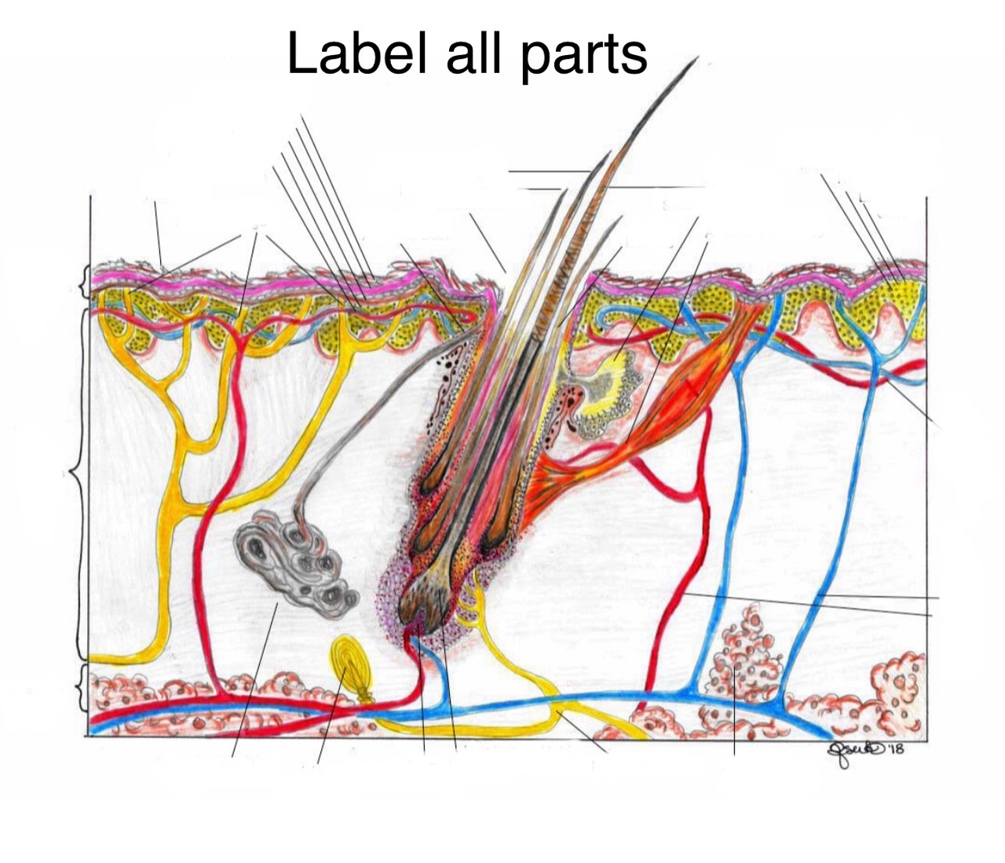

**Please list the 4 types of hair and their function:**

**1.**

**2.**

**3.**

**4.**

**Please list the 4 PRIMARY growth phases of hair:**

**1.**

**2.**

**3.**

**4.**

**What hair phase is responsible for hair follicle dormancy?**

**Please briefly explain the function of each of these dermal appendages:**

1. **Pascinian Corpuscle:**
2. **Arrector Pili Muscle:**
3. **Sebaceous gland:**
4. **Apocrine gland:**
5. **Eccrine gland:**
6. **Ceruminous gland (in the ear canal):**
7. **Dermal Nerve Endings:**

**Please list the 5 layers of the epidermis and explain their action:**

**1.**

**2.**

**3.**

**4.**

**5.**

**Please list the 3 layers of the canine integumentary system:**

**1.**

**2.**

**3.**

**Please list 3 of the counterparts in the epidermis, and explain their function:**

**1.**

**2.**

**3.**

**Please list 5 coat types and list the products best suited for addressing overall care of asymptomatic skin & hair for each coat type.**

**1.**

**2.**

**3.**

**4.**

**5.**

**Choose 3 types of active ingredients in shampoos, and list what symptoms they would best address.**

**1.**

**2.**

**3.**

**Please list 3 common zoonotic diseases.**

**1.**

**2.**

**3.**

**List the 3 different types of cleaning recommended for the salon.**

**1.**

**2.**

**3.**

**Please list 7 things to look for during check in and pet evaluation.**

**1.**

**2.**

**3.**

**4.**

**5.**

**6.**

**7.**

**Please list 3 types of symptomatic coats and what methods and products to utilize to help address those symptoms.**

**1.**

**2.**

**3.**

**Please explain your professional interest in attaining your CCE:**

**Please explain how you would like to utilize your CCE and new knowledge for your clients and business:**